COURSE NAME: Theory of Computation COURSE CODE: CSA1310

COURSE OUTCOME COVERED

CO1: Apply mathematical foundations such as formal proofs, induction, and basic concepts of automata theory to solve computational problems (BL:3)

Assessment Tool Weightage: 10%

QUESTIONS: 5 Total Marks:50
Duration : 1 Hour

Technical Presentation

Code of Conduct:

I T. Divya (192411120) (Name / Reg No) certify that this submission is my original work and that I have adhered to the guidelines specified for this assessment.
I understand that any violation of academic integrity rules will result in disciplinary action.

Signature of the student:

1.How can every Non-Deterministic Finite Automaton (NFA) be converted into an equivalent Deterministic Finite Automaton (DFA), and what are the challenges involved? Consider the NFA given below which accepts some language L over the alphabet 𝚺={0,1}. Construct a DFA that represents the same language L
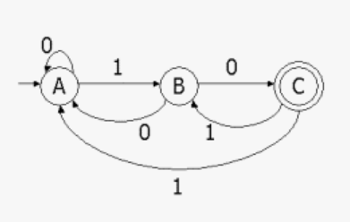

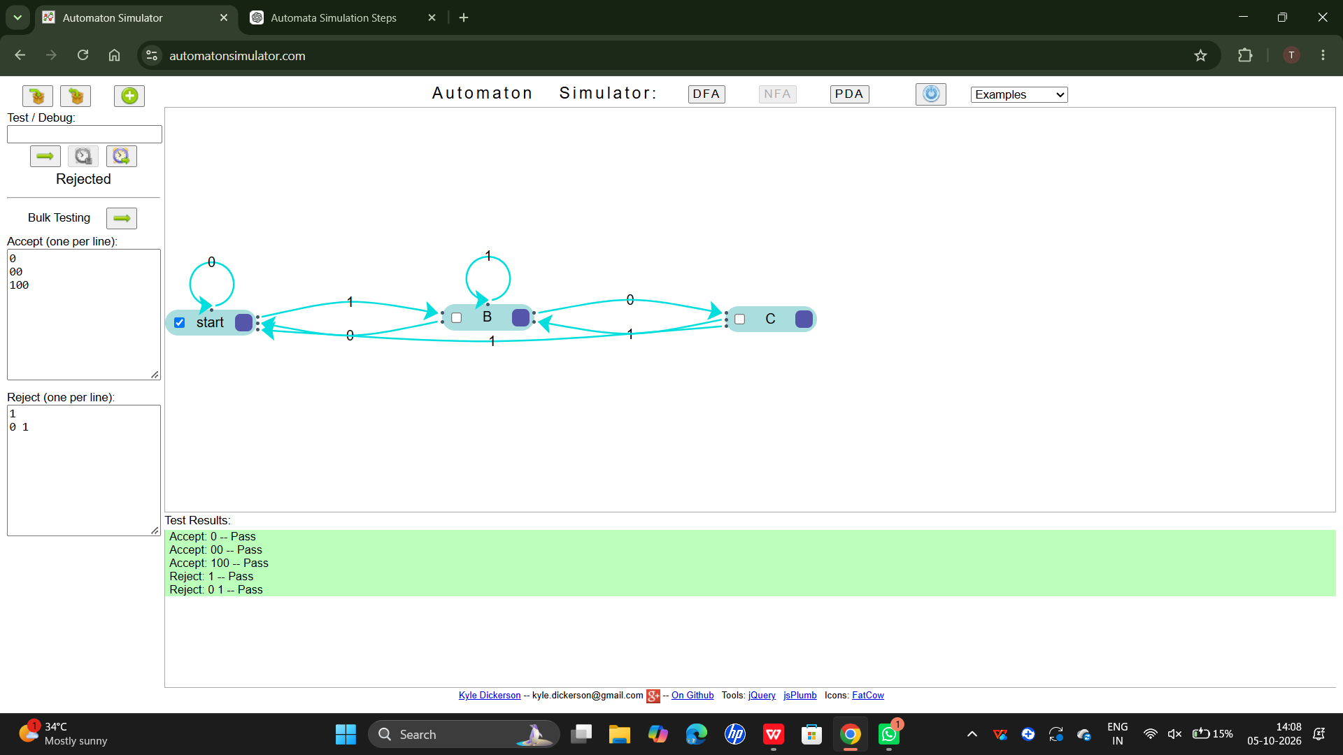
2.How is mathematical induction used to prove properties of strings and languages in automata theory? Apply the principle of mathematical induction and prove that for all positive integers n, the statement given below is true.
$$\sum_{i=1}^{n}{}i^{2}=\frac{n(n+1)(2n+1)}{6}$$

3.What role do epsilon (ε) transitions play in finite automata, and how can ε-NFA be converted into an equivalent NFA without epsilon transitions? construct an equivalent NFA without ε-transitions that accepts the same language. Draw its transition table and mark the initial and final states

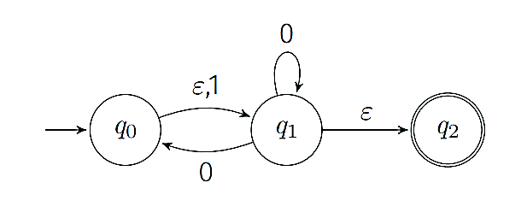

4.A NFA with ε-transitions is given below. Find ε-closure for each state and construct an equivalent DFA which accepts the same language. Draw its transition table and mark the initial and final states
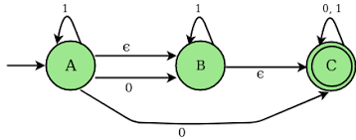

RUBRICS FOR CALCULATION

Criteria | Weightage | Q1 (10) | Q2 (10) | Q3 (10) | Q4 (10) | Q5 (10) | Total Marks (50)
Conceptual Understanding | 30 | 3 | 3 | 3 | 3 | 3 | 15
Accuracy of Answer | 25 | 2.5 | 2.5 | 2.5 | 2.5 | 2.5 | 12.5
Application of Knowledge | 20 | 2 | 2 | 2 | 2 | 2 | 10
Completeness of Response | 15 | 1.5 | 1.5 | 1.5 | 1.5 | 1.5 | 7.5
Clarity & Presentation | 10 | 1 | 1 | 1 | 1 | 1 | 5
Total per Question | 10 Marks | /10 | /10 | /10 | /10 | /10 | / 50

100

